**Basic Data Structure Assignment**

**Q1:** Find out if the given number is an Armstrong number or not.

**Description :-**

An Armstrong number of three digits is an integer, where the sum of the cubes of its digits is equal to the number itself.

Consider the example: 371=> 3^3 + 7^3 + 1^3 = 371 ( If you add those all numbers, the final digit should be same as given number ).

**Code:**

package basic;

public class armstrongNum {

public static void main(String[] args) {

System.***out***.println("Armstrong Number");

int num=371, original, rem, total=0;

original = num;

while(original != 0) {

rem = original%10;

total = total + (rem*rem*rem);

original/=10;

}

if(total == num) {

System.***out***.println(num +" Armstrong Number");

}

else {

System.***out***.println(num + " Not Armstrong Number");

}

}

}

**Output**

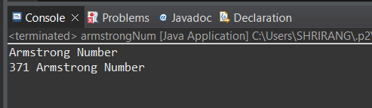

**Q2**. Find out all the Armstrong numbers falling in the range of 100-999

Description :-

An Armstrong number of three digits is an integer, where the sum of the cubes of its digits is equal to the number itself.

Consider the example: 371=> 3^3 + 7^3 + 1^3 = 371 ( If you add those all numbers, the final digit should be same as given number ).

Find the Armstrong numbers between 100 to 999.

**Test cases:**

Output : 153 370 371 407

**Code:**

package basic;

public class armstrong100to999 {

static boolean armstrongNum(int num) {

int original, rem, total=0;

original = num;

while(original != 0) {

rem = original%10;

total = total + (rem*rem*rem);

original/=10;

}

if(total == num) {

return true;

}

else {

return false;

}

}

public static void main(String[] args){

for(int i=100; i<=999; i++) {

if(*armstrongNum*(i)) {

System.***out***.println(i + " ");

}

}

}

}

Output

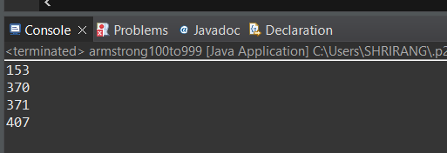

**Q3.** Find out the simple as well as the compound interest of supplied value

Description:-

Simple Interest:- Generally, simple interest paid or received over a certain period is a fixed percentage of the principal amount that was borrowed or lent

Simple Interest = (P×r×n)/100

where:

P = Principal amount

r = Annual interest rate

n = Term of loan, in years

Compound Interest:-Compound interest accrues and is added to the accumulated interest of previous periods; it includes interest on interest, in other words.

Compound Interest = P(1+r)^t-P

Where:

P=Principal amount

r=Annual interest rate

t=Number of years interest is applied

Code:

package javaAssignment;

class SiCi{

public double simpleInterest(double principalAmount, int time, double interestRate) {

double interest = (principalAmount * time * interestRate) / 100;

System.***out***.println("Simple interest "+ interest);

return 0;

}

public double compoundInterest(double principalAmount, int time, double interestRate) {

double interest = principalAmount * (Math.*pow*((1 + interestRate/100), (time * 365))) - principalAmount;

System.***out***.println("Compound Interest "+interest);

return 0;

}

}

public class Assignment1Q3 {

public static void main(String args[]) {

SiCi simple = new SiCi();

simple.simpleInterest(5000,10,20);

System.***out***.println(simple);

SiCi complex = new SiCi();

complex.compoundInterest(5000, 10, 20);

System.***out***.println(complex);

}

}

**Output**

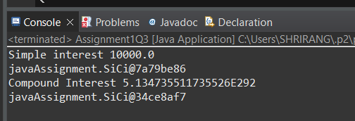

**Q4:** Supply marks of three subject and declare the result, result declaration is based on below conditions:

Condition 1: -All subjects marks is greater than 60 is Passed

Condition 2: -Any two subjects marks are greater than 60 is Promoted

Condition 3: -Any one subject mark is greater than 60 or all subjects’ marks less than 60 is failed.

**Description:-**

Specify the marks of 3 subjects and the results will be declared based on the conditions above and for reference go through the test cases for better understanding.

**Test cases:-**

TestCase1:-

Input:- 10 10 10

Output:- failed

TestCase2:-

Input:- 70 10 10

Output:- failed

TestCase3:-

Input:-70 80 60

Output:- passed

TestCase4:-

Input:-70 60 40

Output:- promoted

**Code:**

package javaAssignment;

class ResultDeclaration{

public String declareResults( double subject1Marks, double subject2Marks, double subject3Marks) {

System.***out***.println(subject1Marks + " " + subject2Marks + " "+ subject3Marks);

if(subject1Marks >= 60.0 && subject2Marks >= 60.0 && subject3Marks >= 60.0) {

System.***out***.println("passed");

}

else if ((subject1Marks >= 60.0 && subject2Marks >= 60.0 && subject3Marks < 60.0)

|| (subject1Marks >= 60.0 && subject2Marks < 60.0 && subject3Marks >= 60.0)

|| (subject1Marks < 60.0 && subject2Marks >= 60.0 && subject3Marks >= 60.0)) {

System.***out***.println("promoted");

}

else {

System.***out***.println("Failed");

}

return null;

}

}

public class Assignment1Q4 {

public static void main(String[] args) {

ResultDeclaration result1 = new ResultDeclaration();

result1.declareResults(70 ,80 , 40);

}

}

**Output:**

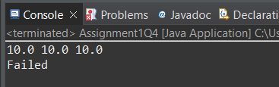

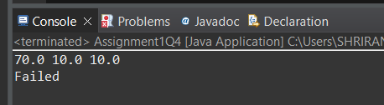

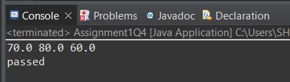

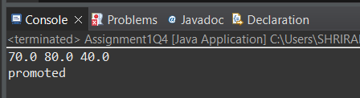

**Q5** Calculate the income tax on the basis of following table.

Note:-Assume slab is consider for Male, Female as well as Senior citizen

Slab Income Range Tax payable in Percentage

Slab A 0-1,80,000 Nil

Slab B 1,81,001-3,00,000 10%

Slab C 3,00,001-5,00,000 20%

Slab D 5,00,001-10,00,000 30%

Accept CTC from user and display tax amount

Description:-

Given 4 different types of slabs along with the percentage of tax payable in association with income ranges which are applicalble to Male,Female as well as Senior citizen.You need to specify the CTC to display the taxable amount using the above slab rates.

**Code:**

package javaAssignment;

import java.util.*;

class TaxAmount{

public double calculateTaxAmount(int ctc){

double amount;

if(ctc <= 180000) {

amount = ctc;

}

else if (ctc > 180000 && ctc <= 300000) {

amount = ctc - ctc * 0.1;

}

else if(ctc>300000 && ctc <= 500000) {

amount = ctc - ctc * 0.2;

}

else {

amount = ctc - ctc * 0.3;

}

System.***out***.println("Taxable Income : "+amount);

return ctc;

}

}

public class Assignment1Q5 {

public static void main(String[] args) {

TaxAmount amount1 = new TaxAmount();

amount1.calculateTaxAmount(10000000);

}

}

**Output:**

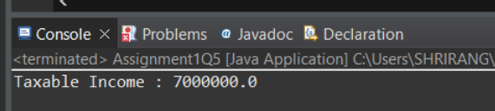

**Q6** Consider a CUI based application, where you are asking a user to enter his Login name and password, after entering the valid user-id and password it will print the message “Welcome” along with user name. As per the validation is concerned, the program should keep a track of login attempts. After three attempts a message should be flashed saying “Contact Admin” and the program should terminate.

**Code**

package javaAssignment;

import java.util.*;

public class Assignment1Q6 {

static String *userId* = "Ajay";

static String *password* = "password";

static boolean loginuser(String user, String pass) {

if (*userId*.equals(user) && *password*.equals(pass)) {

return true;

}

else {

return false;

}

}

public static void main(String[] args) {

try(Scanner sc = new Scanner(System.***in***)){

String user, pass;

int attempt = 0;

do {

System.***out***.println("Enter userId : ");

user = sc.next();

System.***out***.println("Password : ");

pass = sc.next();

boolean ans =*loginuser*(user, pass);

if(ans == true) {

System.***out***.println("Welcome Ajay");

break;

}

else if(ans == false && attempt <3) {

System.***out***.println("You have entered wrong credentials ,please enter the right credentials.");

attempt +=1;

}

}while(attempt != 3);

if (attempt >= 3) {

System.***out***.println("\n Contact Admine !!!\n");

}

}

}

}

Output:

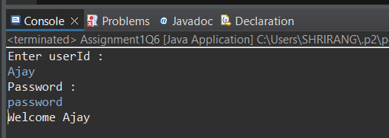

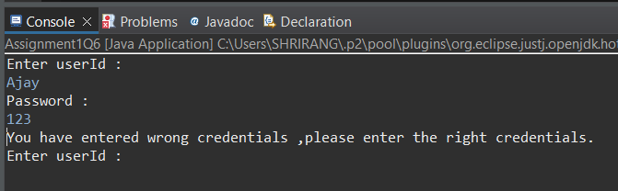

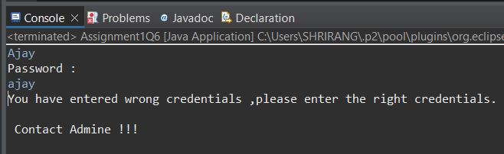

**Q7** There is an Array which is of the size 15, which may or may not be sorted. You should write a program to accept a number and search if it in contained in the array

Example:

5 12 14 6 78 19 1 23 26 35 37 7 52 86 47

Value to be search is 19

Description:-

Given an array, the task is to check whether a certain element is present in this given Array or not.

**Code**

package javaAssignment;

public class Assignment1Q7 {

static boolean searchArray1(int[] arr, int toCheckValue) {

boolean ans = false;

for(int i=0; i<arr.length; i++) {

if(arr[i]==toCheckValue) {

ans = true;

break;

}

}

return ans;

}

public static void main(String[] args) {

int arr[] = { 5,12,14,6,78,19,1,23,26,35,37,7,52,86,47};

int valueToCheck = 19;

boolean ans = *searchArray1*(arr, valueToCheck);

if(ans == true) {

System.***out***.println("Number is Found!!");

}

else {

System.***out***.println("Number is not found!!");

}

}

}

**Output**

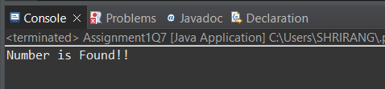

**Q8** Using the below table write method apply sorting using Bubble Sort.

Example:

5 12 14 6 78 19 1 23 26 35 37 7 52 86 47

Description:-

Bubble sort is a simple sorting algorithm. This sorting algorithm is comparison-based algorithm in which each pair of adjacent elements is compared and the elements are swapped if they are not in order. This algorithm is not suitable for large data sets as its average and worst case complexity are of Ο(n2) where n is the number of items.

Example-

Input : 5 12 14 6 78 19 1 23 26 35 37 7 52 86 47

Output: 1 5 6 7 12 14 19 23 26 35 37 47 52 78 86

**Code**

package javaAssignment;

public class Assignment1Q8 {

static int[] bobbleSort(int arr[]) {

for (int i =0; i<arr.length; i++) {

for(int j = i+1;j<arr.length; j++ ) {

if(arr[i] > arr[j]) {

int temp = arr[i];

arr[i] = arr[j];

arr[j] = temp;

}

}

}

return arr;

}

public static void main(String[] args) {

int arr[] = {5,12,14,6,78,19,1,23,26,35,37,7,52,86,47};

arr = *bobbleSort*(arr);

*bobbleSort*(arr);

System.***out***.println("Array after sorting : ");

for(int i=0; i < arr.length; i++) {

System.***out***.println(arr[i]+ " ");

}

System.***out***.println();

}

}

**Output**

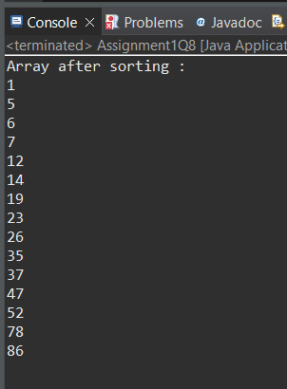

**Q9** **Accept the marks of three students for the subject A, B, C. Find the total scored and the average in all the subjects. Also Find the Total and Average scored by students in each respective Subject.**

**Description:-**

Enter the marks of 3 students for subjects A,B,C. Find the total marks secured by respective student in all the subjects and also find the total and average scored by students subject wise.

**Example:-**

              Sample Input:-

                             marks of Student 1 in subjects A,B,C

                                           10 20 30

                             marks of Student 2 in subjects A,B,C

                                           10 20 30

                             marks of Student 3 in subjects A,B,C

                                           10 20 30

              Sample Output:-

                             180                                    //Total marks of all the students in all subjects

                             60.0                                   //Average marks of all the students in all subjects

                             30                                       // Total marks scored by students in subject A

                             10.0                                   // Average marks scored by students in subject A

                             60                                       // Total marks scored by students in subject B

                             20.0                                   // Average marks scored by students in subject B

                             90                                       // Total marks scored by students in subject C

                             30.0                                   // Average marks scored by students in subject C

**Code**

package javaAssignment;

import java.util.Scanner;

public class Assignment1Q9 {

static int *subjectA*, *subjectB*, *subjectC*;

static int studentsTotalMarksInAllSubjects(int[] marks) {

int sum = 0;

for (int i = 0; i <9; i++) {

sum += marks[i];

}

return sum;

}

static double studentsAverageMarksInAllSubjects(int[] marks) {

int sum = *studentsTotalMarksInAllSubjects*(marks);

int avg = sum / 3;

return avg;

}

static int subjectATotalByStudents(int[] marks) {

int sum = 0;

for (int i = 0; i <9; i += 3) {

sum += marks[i];

}

return sum;

}

static int subjectBTotalByStudents(int[] marks) {

int sum = 0;

for (int i = 1; i <9; i += 3) {

sum += marks[i];

}

return sum;

}

static int subjectCTotalByStudents(int[] marks) {

int sum = 0;

for (int i = 2; i <9; i += 3) {

sum += marks[i];

}

return sum;

}

static double subjectAAverageByStudents(int[] marks) {

int sum = *subjectATotalByStudents*(marks);

double avg = sum / 3;

return avg;

}

static double subjectBAverageByStudents(int[] marks) {

int sum = *subjectBTotalByStudents*(marks);

double avg = sum / 3;

return avg;

}

static double subjectCAverageByStudents(int[] marks) {

int sum = *subjectCTotalByStudents*(marks);

double avg = sum / 3;

return avg;

}

public static void main(String[] args) {

int[] Student1 = new int[3];

int[] Student2 = new int[3];

int[] Student3 = new int[3];

int[] marks = new int[9];

int j = 0;

try (Scanner sc = new Scanner(System.***in***)) {

System.***out***.println("Enter the marks for student 1:");

for (int i = 0; i <= 2; i++) {

System.***out***.print("Subject : ");

Student1[i] = sc.nextInt();

marks[j] = Student1[i];

j++;

}

System.***out***.println("\nEnter the marks for student 2:");

for (int i = 0; i <= 2; i++) {

System.***out***.print("Subject : ");

Student2[i] = sc.nextInt();

marks[j] = Student2[i];

j++;

}

System.***out***.println("\nEnter the marks for student 3:");

for (int i = 0; i <= 2; i++) {

System.***out***.print("Subject : ");

Student3[i] = sc.nextInt();

marks[j] = Student3[i];

j++;

}

System.***out***.println("Total marks of all the students in all subjects: " + *studentsTotalMarksInAllSubjects*(marks));

System.***out***.println("Average marks of all the students in all subjects: " + *studentsAverageMarksInAllSubjects*(marks));

System.***out***.println("Total marks scored by students in subject A: " + *subjectATotalByStudents*(marks));

System.***out***.println("Average marks scored by students in subject A: " + *subjectAAverageByStudents*(marks));

System.***out***.println("Total marks scored by students in subject B: " + *subjectBTotalByStudents*(marks));

System.***out***.println("Average marks scored by students in subject B: " + *subjectBAverageByStudents*(marks));

System.***out***.println("Total marks scored by students in subject C: " + *subjectCTotalByStudents*(marks));

System.***out***.println("Average marks scored by students in subject C: " + *subjectCAverageByStudents*(marks));

}

}

}

**Output**

